Computer Science Internal Assessment

Internal Assessment of a programmatic approach/solution to solve the stress and strain of administrative workload and duties of the academic institution Oakland Group of Schools.

Group Members: Colin Campbell, Ronae Thompson, Trent Mackenzie

Academic Year:

2018 - 2019

**Table of Contents**

**Problem Definition** 2

**Narrative** 3

**Pseudocode** 8

**The Implementation** 24

**Main.c** 24

**Screens.h** 26

**Utils.h** 35

**Screenshots** 43

# **Problem Definition**

Oakland Group of Schools is located in the parish of St. Catherine Jamaica. It was founded by Pastor Oakland Whyte in the year 1984. The school contact information is (876) 989-2343. In the year 1984 the school started out with a population of 20 students, presently the school has 170 students’ grades 1-6 with 6 teachers on campus. The school offers English, Math, Social Studies and General Science. The native method the teachers used to get reports to students was by hand. Currently, the teachers at the school have been using excel, access and the web to get the report to the students.

This current process is described by teachers as being too time-consuming as they have to be moving from one program to another to get the student’s reports ready for each term. This result in inaccurate grades being placed at student’s names. This results in students receiving a grade that does not reflect their academic performance. Teachers also brought up the issue of security and requested for a system that was secure and allowed only authorized persons to have access to the different subject departments.

The program that will be created that should store the names of the teachers and their class. The password for each teacher will be pre-set. When the teacher inputs the correct password, they will now have access to their class which they can now enter the term the current year, the name of the students, their age, their sex and the grades they got for each subject.

The program will then be able to output the report for the class which includes the name of the class, the number of students within the class, the grade of the class including the top achiever for each subject as well as the top achiever for that class. The program should also produce a report for each student show their name, class, age, grades for each subject and their average. The content of the file should show on the screen for the teacher’s viewing.

# **Narrative**

**Procedure Main**

**Start**

Prompt user to add class, remove class, get class report and manage class

Get input that corresponds with the user’s actions

If user wants to add class call procedure addClass

If user wants to remove class call procedure removeClass

If user wants to get class report call procedure getClassReport

If user wants to manage class call procedure mngClass

Ask the user if they want to exit the program, if they don’t rub main again

**Stop**

**Procedure addClass**

**Start**

Prompt user for the name of the class

Create a text file with .txt extension, with the class name as the name of the class

Prompt user for their user name and password for the class

Write the username and password at the top of the file

Prompt the user to enter the amount of students they wish to enter

Prompt the user to enter the names and the average grades for the students for the subjects, integrated science, physical education, English and mathematics

Write the information from each student, line by line, with every information separated by tabs

Close the file

**Stop**

**Procedure removeClass**

**Start**

Prompt the user the name of the class

Check if the file exists

If the file exists, prompt the user their username and password for that class

Read the username and password from the top of the file

Check If the read username and password and the input username and password matches

If the corresponding variables are equal to each other call a built in method to delete the file

**Stop**

**Procedure manageClass**

**Start**

Prompt user if they would like to add student to a class or remove student from a class

Get the value that corresponds with their actions

If the user wishes to remove student from a class call sub routine removeStudent

If the user wishes to add student to a class, call sub routine addStudent

**Stop**

**Procedure addStudent**

**Start**

Prompt user for the class that they’d like to add student to

Open the file

Prompt user name and password from the user

Read the top of the file and check if the corresponding variables are equal

If the variables are equal prompt for the name of the student, they’d like to add and the grades for the four subjects

Close the reopen the file in append mode to append the student name and their grades for each subject, all separated by tab

Close the file

**Stop**

**Procedure removeStudent**

**Start**

Prompt user for the class that they’d like to add student to

Open the file

Prompt user name and password from the user

Read the top of the file and check if the corresponding variables are equal

If the variables are equal prompt for the name of the student they like to remove.

Read the file, including the username and the password at the top of the file, and the student’s information in the file

Store the student information and the teacher’s information in arrays and interim varibles

Close the file

Delete the file

Create the file with the same class name, write the teacher’s information to the newly created file, and thereafter the students’ information, skipping the student prompted to be removed using continue statement

Close the file

**Stop**

**Procedure getClassRpt**

**Start**

Prompt user for the class that they’d like to add student to

Open the file

Prompt user name and password from the user

Read the top of the file and check if the corresponding variables are equal

Read the file for students’ information into an array

Calculate the highest values for maths, English, physical education and integrates science.

Print to the screen, the students’ names, grades for each subject, and the students who score high for each subject.

**Stop**

# **Pseudocode**

Main C

|  |
| --- |
| StartAlgorithm: integer main () |
|  |  |
|  |  |
|  | exit 🡨 0 |
|  | option 🡨 0 |
|  |  |
|  | while ( exit 🡨 0) do |
|  |  |
|  | char decision 🡨 0 |
|  | option 🡨 menu() |
|  | DoCase (option) |
|  |  |
|  | case 1 : addClass() |
|  | break |
|  | case 2 : removeClass() |
|  | break |
|  | case 3 : getClassRpt() |
|  | break |
|  | case 4 : mngClass() |
|  | break |
|  | case 6 : break |
|  | EndCase |
|  |  |
|  | Write("Would you like to terminate the program ? y/n ") |
|  | fflush(stdin) |
|  | Read (decision) |
|  |  |
|  | if ( decision 🡨 “y”) |
|  | exit 🡨 1 |
|  | else if (decision 🡨 “n”) |
|  | exit 🡨 0 |
|  | else |
|  | EndIf |
|  |  |
|  | Write("Sorry the input is not regonised, try using lower case, not upper case letters") |
|  | Write("Would you like to terminate the program ? y/n ") |
|  | fflush(stdin) |
|  | Read (decision) |
|  |  |
|  | if ( decision 🡨 ”y”) |
|  | exit 🡨 1 |
|  | else if (decision 🡨 ”n”) |
|  | exit 🡨 0 |
|  | EndIf |
|  | Write (NEWLINE) |
|  | EndWhile |
|  | Stop |

SCREEN.H

|  |
| --- |
|  |
|  | NEWLINE 🡨 "\n" |
|  |  |
|  |  |
|  |  |
|  | menu() |
|  | Start |
|  | option 🡨 0 |
|  |  |
|  | Write("Please chose the number that corresponds with the actions you will like to commit :") |
|  | Write(NEWLINE) |
|  | Write("1) Add a class.") |
|  | Write(NEWLINE) |
|  | Write("2) Remove a class") |
|  | Write(NEWLINE) |
|  | Write("3) Get a class report") |
|  | Write(NEWLINE) |
|  | Write("4) Manage class") |
|  | Write(NEWLINE) |
|  | Write("6) Undecided") |
|  | Write(NEWLINE) |
|  |  |
|  | flushBuffer() |
|  | Write("What do wish to do : ") |
|  | Read(option) |
|  |  |
|  | return option |
|  | Stop |
|  |  |
|  | Start Algorithm: void addClass() |
|  |  |
|  | char cName[40] |
|  | char tName[40] |
|  | char tPass[40] |
|  |  |
|  | Write(NEWLINE) |
|  | Write("|\t|\t|\t|\t Add Class \t|\t|\t|\t|") |
|  | Write(NEWLINE) |
|  |  |
|  | Write("Please enter the class's name : ") |
|  | flushBuffer() |
|  | gets(cName) |
|  |  |
|  | Write("Please enter username : ") |
|  | flushBuffer() |
|  | gets(tName) |
|  |  |
|  | Write ("Please enter password for the class : ") |
|  | flushBuffer() |
|  | gets(tPass) |
|  |  |
|  | createClass(cName,tName,tPass) |
|  | Stop Algorithm |
|  |  |
|  | Start Algorithm: void removeClass() |
|  |  |
|  | char className[40] |
|  | char tUsername[40] |
|  | char tPassword[40] |
|  |  |
|  | Write ("Please enter the name of the class you'd like to delete : ") |
|  | flushBuffer() |
|  | gets(className) |
|  |  |
|  | strcat(className,".txt") |
|  |  |
|  | FILE *fp |
|  | fp 🡨 fopen(className,"r") |
|  | If (!fp) then |
|  |  |
|  | Write("Class not found",className) |
|  | fclose(fp) |
|  |  |
|  | EndIF |
|  |  |
|  | Write("Please enter username : ") |
|  | flushBuffer() |
|  | gets(tUsername) |
|  |  |
|  | Write("Please enter password for class : ") |
|  | flushBuffer() |
|  | gets(tPassword) |
|  |  |
|  |  |
|  | If (fp) then |
|  |  |
|  | char readUsername[40] |
|  | char readPassword[40] |
|  | fscanf(fp,"%s\t%s",readUsername,readPassword) |
|  | fclose(fp) |
|  | if (strcmp(readPassword,tPassword) 🡨 0 && |
|  | strcmp(readUsername,tUsername) 🡨 0) |
|  |  |
|  | status 🡨 remove(className) |
|  | Write ("Status :",status) |
|  | else |
|  | Write ("User name and/or password is incorrect") |
|  | else |
|  |  |
|  | Write ("File not found",className) |
|  | EndIf |
|  |  |
|  | EndIf |
|  |  |
|  | Start Algorithm: void getClassRpt() |
|  |  |
|  | char tUsername[40] |
|  | char tPassword[40] |
|  | char className[40] |
|  |  |
|  | Write (NEWLINE) |
|  | Write ("|\t|\t|\t|\t Class Report \t|\t|\t|\t|") |
|  | Write (NEWLINE) |
|  | Write (NEWLINE) |
|  |  |
|  | Write ("Please enter class you'd like to get report from : ") |
|  | flushBuffer() |
|  | gets(className) |
|  |  |
|  | strcat(className,".txt") |
|  | FILE *fp 🡨 fopen(className,"r") |
|  |  |
|  | Write ("Please enter usename : ") |
|  | flushBuffer() |
|  | gets(tUsername) |
|  |  |
|  | Write ("Please enter password : ") |
|  | flushBuffer() |
|  | gets(tPassword) |
|  |  |
|  | bool isLogged 🡨 loginTeacher(tUsername,tPassword,fp) |
|  |  |
|  | struct Student students[100] |
|  |  |
|  | If (isLogged) then |
|  |  |
|  |  |
|  | x 🡨 0 |
|  | i 🡨 0 |
|  |  |
|  | char heighestAverageStudent[40] |
|  | heighestAverage 🡨 0 |
|  |  |
|  | char heighestEngStudent[40] |
|  | heighestEng 🡨 0 |
|  |  |
|  | char heighestPhysEdStudent[40] |
|  | heighestPhyEd 🡨 0 |
|  |  |
|  | char heighestMathStudent[40] |
|  | heighestMath 🡨 0 |
|  |  |
|  | char heighestInteSciStudent[40] |
|  | heighestInteSci 🡨 0 |
|  |  |
|  | While (x ! 🡨 EOF) |
|  |  |
|  | struct Student student |
|  | x 🡨 fscanf(fp,"%s\t%d\t%d\t%d\t%d\n",student.fullName,&student.mathGrade,&student.engGrade,&student.phyEdGrade,&student.inteSciGrade) |
|  |  |
|  |  |
|  | strcpy(students[i].fullName,student.fullName) |
|  | students[i].mathGrade 🡨 student.mathGrade |
|  | students[i].engGrade 🡨 student.engGrade |
|  | students[i].phyEdGrade 🡨 student.phyEdGrade |
|  | students[i].inteSciGrade 🡨 student.inteSciGrade |
|  |  |
|  |  |
|  | If (students[i].mathGrade > heighestMath) then |
|  |  |
|  | heighestMath 🡨 students[i].mathGrade |
|  | strcpy(heighestMathStudent,students[i].fullName) |
|  | EndIf |
|  |  |
|  | if (students[i].engGrade > heighestEng) then |
|  |  |
|  | heighestEng 🡨 students[i].engGrade |
|  | strcpy(heighestEngStudent,students[i].fullName) |
|  | EndIf |
|  |  |
|  | if (students[i].phyEdGrade > heighestPhyEd) then |
|  |  |
|  | heighestPhyEd 🡨 students[i].phyEdGrade |
|  | strcpy(heighestPhysEdStudent,students[i].fullName) |
|  | EndIf |
|  |  |
|  | if (students[i].inteSciGrade > heighestInteSci) then |
|  |  |
|  | heighestInteSci 🡨 students[i].inteSciGrade |
|  | strcpy(heighestInteSciStudent,students[i].fullName) |
|  | EndIf |
|  |  |
|  | i++ |
|  | EndWhile |
|  |  |
|  | i 🡨 i-1 |
|  | j 🡨 0 |
|  | Write("Student Name/Math Average Grade/English Average Grade/Integrated Science Average Grade/Physical Education Average Grade/Overall Average") |
|  | while ( j < i) |
|  |  |
|  | averageGrade 🡨 (students[j].mathGrade + students[j].engGrade + students[j].inteSciGrade + students[j].phyEdGrade)/4 |
|  | Write("",students[j].fullName,students[j].mathGrade,students[j].engGrade,students[j].inteSciGrade,students[j].phyEdGrade,averageGrade) |
|  | j++ |
|  | EndWhile |
|  |  |
|  | Write("Heighest average in mathematics ",heighestMath,heighestMathStudent) |
|  | Write("Heighest average in english",heighestEng,heighestEngStudent) |
|  | Write("Heighest average in integrated science  ",heighestInteSci,heighestInteSciStudent) |
|  | Write("Heighest average in physical education ",heighestPhyEd,heighestPhysEdStudent) |
|  |  |
|  | EndIf |
|  |  |
|  | Stop Algorithm |
|  |  |
|  | Start Algorithm: void mngClass() |
|  |  |
|  | option 🡨 0 |
|  |  |
|  | Write (NEWLINE) |
|  | Write ("|\t|\t|\t|\t Manage Class \t|\t|\t|\t|") |
|  | Write (NEWLINE) |
|  | Write (NEWLINE) |
|  |  |
|  | Write ("Please chose the number that corresponds with the actions you will like to commit :") |
|  | Write (NEWLINE) |
|  | Write (NEWLINE) |
|  |  |
|  | Write ("1) Add Student to a class.") |
|  | Write (NEWLINE) |
|  |  |
|  | Write ("2) Remove Student from a class.") |
|  | Write (NEWLINE) |
|  |  |
|  | Write ("What would like to do : ") |
|  | Read(option) |
|  |  |
|  | if (option 🡨 1) then |
|  | addStudent() |
|  | else if(option 🡨 2) |
|  | removeStudent() |
|  | else |
|  |  |
|  | Write ("The value you entered is not recognised") |
|  | Write (NEWLINE) |
|  | return |
|  | EndIf |
|  | Stop Algorithm  UTILS.H   |  |  | | --- | --- | |  |  | |  | void addStudents(FILE *) | |  |  | |  |  | |  | Start Algorithm: void flushBuffer() | |  |  | |  | fflush(stdin) | |  | Stop Algorithm | |  |  | |  |  | |  |  | |  |  | |  | Start Algorithm: void createClass(char cName[60], char tName[40],char tPass[40]) | |  |  | |  | FILE *ptr | |  |  | |  | /**strcat(location,cName) // concatenate the string path to the file name | |  | strcat(location,".txt") | |  | strcpy(path,location)**/ | |  |  | |  | char *fileExtension 🡨 ".txt" | |  |  | |  | strcat(cName,fileExtension) | |  | ptr 🡨 fopen(cName,"w") | |  |  | |  | // Error handling | |  | If (ptr) then | |  |  | |  | fprintf(ptr,"%s\t%s\n",tName,tPass) | |  | addStudents(ptr) | |  | Write("Class Created successfully") | |  | fclose(ptr) | |  | else | |  |  | |  | Write (NEWLINE) | |  | perror("Error") | |  | Write (NEWLINE) | |  | exit(1) | |  | EndIf | |  | Stop Algorithm | |  |  | |  | Start Algorithm: bool loginTeacher(char tName[40],char tPass[40],FILE *fp) | |  |  | |  | // copied from removeClass function | |  | If (fp) then | |  |  | |  | char readUsername[40] | |  | char readPassword[40] | |  | fscanf(fp,"%s\t%s\n",readUsername,readPassword) | |  | //fclose(fp) | |  | if (strcmp(readPassword,tPass) 🡨 0 && | |  | strcmp(readUsername,tName) 🡨 0) then | |  |  | |  | return true | |  | else | |  |  | |  | Write ("User name and/or password is incorrect") | |  | return false | |  |  | |  | else | |  |  | |  | return false | |  | EndIf | |  | EndIf | |  |  | |  |  | |  | Start Algorithm: void addStudents(FILE *fp) | |  |  | |  | size 🡨 0 | |  | flushBuffer() | |  | Write ("Please enter the amount of students that are in the class :") | |  | Read(size) | |  | struct Student students[size] | |  |  | |  |  | |  | for (i 🡨 0 i < size) | |  |  | |  | x 🡨 i + 1 | |  | Write ("Please enter student full name : ",x) | |  | flushBuffer() | |  | gets(students[i].fullName) | |  |  | |  | Write ("Please enter student Mathematics average grade : ",x) | |  | flushBuffer() | |  | Read (students[i].mathGrade) | |  |  | |  | Write ("Please enter student English average grade : ",x) | |  | flushBuffer() | |  | Read (students[i].engGrade) | |  |  | |  | Write ("Please enter student Physical Education average grade : ",x) | |  | flushBuffer() | |  | Read (students[i].phyEdGrade) | |  |  | |  | Write ("Please enter student Integrated Science average grade : ",x) | |  | flushBuffer() | |  | Read (students[i].inteSciGrade) | |  | EndFor | |  |  | |  | for ( i 🡨 0 i < size) | |  |  | |  | fprintf(fp,"%s\t%d\t%d\t%d\t%d\n",students[i].fullName,students[i].mathGrade,students[i].engGrade,students[i].phyEdGrade,students[i].inteSciGrade) | |  | EndFor | |  | Stop Algorithm | |  |  | |  | Start Algorithm: void addStudent() | |  |  | |  | char tUsername[40] | |  | char tPass[40] | |  | char className[40] | |  |  | |  | Write ("Please enter the class you'd like to add the student to : ") | |  | flushBuffer() | |  | gets(className) | |  |  | |  | strcat(className,".txt") | |  | FILE *fp 🡨 fopen(className,"r") | |  |  | |  | Write ("Please enter username : ") | |  | flushBuffer() | |  | gets(tUsername) | |  |  | |  | Write ("Please enter password : ") | |  | flushBuffer() | |  | gets(tPass) | |  |  | |  | bool isLogged 🡨 loginTeacher(tUsername,tPass,fp) | |  |  | |  | fp 🡨 fopen(className,"a") | |  |  | |  | If (isLogged) then | |  |  | |  | struct Student student | |  | Write ("Please enter student full name : ") | |  | flushBuffer() | |  | gets(student.fullName) | |  |  | |  | Write ("Please enter student Mathematics average grade : ") | |  | flushBuffer() | |  | Read (student.mathGrade) | |  |  | |  | Write ("Please enter student English average grade : ") | |  | flushBuffer() | |  | Read (student.engGrade) | |  |  | |  | Write ("Please enter student Physical Education average grade : ") | |  | flushBuffer() | |  | Read (student.phyEdGrade) | |  |  | |  | Write ("Please enter student Integrated Science average grade : ") | |  | flushBuffer() | |  | Read (student.inteSciGrade) | |  | fprintf(fp,"%s\t%d\t%d\t%d\t%d\n",student.fullName,student.mathGrade,student.engGrade,student.phyEdGrade,student.inteSciGrade) | |  | fclose(fp) | |  |  | |  | Write ("Student added successfully") | |  | EndIf | |  | Stop Algorithm | |  |  | |  | Start Algorithm: void removeStudent() | |  |  | |  | char tUsername[40] | |  | char tPass[40] | |  | char className[40] | |  | char studentName[40] | |  |  | |  | Write ("Please enter the class you'd like to add the student to : ") | |  | flushBuffer() | |  | gets(className) | |  |  | |  | strcat(className,".txt"); // add .txt to the file extension | |  | FILE *fp 🡨 fopen(className,"r") | |  |  | |  | Write ("Please enter username : ") | |  | flushBuffer() | |  | gets(tUsername) | |  |  | |  | Write ("Please enter password : ") | |  | flushBuffer() | |  | gets(tPass) | |  |  | |  | Write ("Please enter student that you'd like to remove : ") | |  | flushBuffer() | |  | gets(studentName) | |  |  | |  | struct Student students[100] | |  |  | |  | bool isLogged 🡨 loginTeacher(tUsername,tPass,fp) | |  |  | |  | If (isLogged) then | |  |  | |  | x 🡨 1 | |  | i 🡨 0 | |  |  | |  | struct Student student | |  |  | |  | while (x ! 🡨 EOF) | |  |  | |  | x 🡨fscanf(fp,"%s\t%d\t%d\t%d\t%d\n",student.fullName,&student.mathGrade,&student.engGrade,&student.phyEdGrade,&student.inteSciGrade) | |  | Write ("Name : i 🡨",student.fullName,i) | |  |  | |  | strcpy(students[i].fullName,student.fullName) | |  | students[i].mathGrade 🡨 student.mathGrade | |  | students[i].engGrade 🡨 student.engGrade | |  | students[i].phyEdGrade 🡨 student.phyEdGrade | |  | students[i].inteSciGrade 🡨 student.inteSciGrade | |  | i++ | |  | EndWhile | |  |  | |  |  | |  | fclose(fp) | |  | remove(className) | |  | j 🡨 i | |  |  | |  | FILE *ptr 🡨 fopen(className,"w") | |  | fprintf(ptr,"%s\t%s",tUsername,tPass) | |  |  | |  | length 🡨 sizeof(students) / sizeof(students[0]) | |  | Write (" j :",j) | |  |  | |  | for ( i 🡨 0; i < length) | |  |  | |  | if ( strcmp(studentName,students[i].fullName) 🡨 0) | |  | continue | |  | else if ( i 🡨 j) | |  | break | |  |  | |  | fprintf(ptr,"%s\t%d\t%d\t%d\t%d\n",students[i].fullName,students[i].mathGrade,students[i].engGrade,students[i].phyEdGrade,students[i].inteSciGrade) | |  | EndFor | |  |  | |  | EndIf | |  | Stop Algorithm | |

# **The Implementation**

## **Main.c**

#include <stdio.h>

#include <stdlib.h>

#include "screens.h"

#define NEWLINE "\n"

// @author Colin A. Campbell

// Entry point for program is here

int main()

{

int exit = 0; // sentinel value for the while loop

int option = 0; // value returned to from menu

while ( exit == 0)

{

char decision = 0;

option = menu();

switch (option)

{

case 1 : addClass();

break;

case 2 : removeClass();

break;

case 3 : getClassRpt();

break;

case 4 : mngClass();

break;

case 6 : break;

}

printf("\nWould you like to terminate the program ? y/n ");

fflush(stdin);

scanf("%c",&decision);

if ( decision == 'y')

exit = 1; // 1 means true

else if (decision == 'n')

exit = 0; // 0 mean false

else

{

// Ask the user a second time, if the first input for decision is not recognised

printf("Sorry the input is not regonised, try using lower case, not upper case letters");

printf("Would you like to terminate the program ? y/n ");

fflush(stdin);

scanf("%c",&decision);

if ( decision == 'y')

exit = 1; // 1 means true

else if (decision == 'n')

exit = 0;

}

printf(NEWLINE);

}

}

## **Screens.h**

#include "utils.h"

#define NEWLINE "\n"

extern FILE *ptr;

int menu()

{

int option = 0;

printf("Please chose the number that corresponds with the actions you will like to commit :");

printf(NEWLINE);

printf("1) Add a class.");

printf(NEWLINE);

printf("2) Remove a class");

printf(NEWLINE);

printf("3) Get a class report");

printf(NEWLINE);

printf("4) Manage class");

printf(NEWLINE);

printf("6) Undecided");

printf(NEWLINE);

flushBuffer();// flush out the buffer so it wont overflow fresh values

printf("What do wish to do : ");

scanf("%d",&option);

return option;

}

void addClass()

{

char cName[40]; // class name

char tName[40]; // teacher's name

char tPass[40]; // teacher's password

printf(NEWLINE);

printf("|\t|\t|\t|\t Add Class \t|\t|\t|\t|");

printf(NEWLINE);

printf("Please enter the class's name : ");

flushBuffer();

gets(cName);

printf("Please enter username : ");

flushBuffer();

gets(tName);

printf("Please enter password for the class : ");

flushBuffer();

gets(tPass);

createClass(cName,tName,tPass);

}

void removeClass()

{

char className[40];

char tUsername[40];

char tPassword[40];

// TODO finish up this method

printf("Please enter the name of the class you'd like to delete : ");

flushBuffer();

gets(className);

strcat(className,".txt");

// open file to read line by line

FILE *fp; // fp : file pointer

fp = fopen(className,"r");

if (!fp)

{

printf("Class %s, not found",className);

fclose(fp);

return; // exit the function if fp is null

}

printf("Please enter username : ");

flushBuffer();

gets(tUsername);

printf("Please enter password for class : ");

flushBuffer();

gets(tPassword);

if (fp)

{

char readUsername[40];

char readPassword[40];

fscanf(fp,"%s\t%s",readUsername,readPassword);

fclose(fp); // close the pointer to the file so, the file can be deleted safely

if (strcmp(readPassword,tPassword) == 0 && // strcmp, or string compare, returns 0 if both strings are equal to each other

strcmp(readUsername,tUsername) == 0)

{

int status = remove(className);

printf("Status : %d",status);

} else

printf("User name and/or password is incorrect");

} else

{

printf("File %s, not found\n",className);

}

}

void getClassRpt()

{

char tUsername[40];

char tPassword[40];

char className[40];

printf(NEWLINE);

printf("|\t|\t|\t|\t Class Report \t|\t|\t|\t|");

printf(NEWLINE);

printf(NEWLINE);

printf("Please enter class you'd like to get report from : ");

flushBuffer();

gets(className);

strcat(className,".txt");

FILE *fp = fopen(className,"r");

printf("Please enter usename : ");

flushBuffer();

gets(tUsername);

printf("Please enter password : ");

flushBuffer();

gets(tPassword);

bool isLogged = loginTeacher(tUsername,tPassword,fp);

struct Student students[100];

if (isLogged)

{

// read scan student information to the file

int x = 0;

int i = 0;

char heighestAverageStudent[40];

int heighestAverage = 0;

char heighestEngStudent[40];

int heighestEng = 0;

char heighestPhysEdStudent[40];

int heighestPhyEd = 0;

char heighestMathStudent[40];

int heighestMath = 0;

char heighestInteSciStudent[40];

int heighestInteSci = 0;

while (x != EOF)

{

struct Student student;

x = fscanf(fp,"%s\t%d\t%d\t%d\t%d\n",student.fullName,&student.mathGrade,&student.engGrade,&student.phyEdGrade,&student.inteSciGrade);

//printf("Name : %s, i = %d\n",student.fullName,i);

strcpy(students[i].fullName,student.fullName);

students[i].mathGrade = student.mathGrade;

students[i].engGrade = student.engGrade;

students[i].phyEdGrade = student.phyEdGrade;

students[i].inteSciGrade = student.inteSciGrade;

// calculate the heighest scores

if (students[i].mathGrade > heighestMath)

{

heighestMath = students[i].mathGrade;

strcpy(heighestMathStudent,students[i].fullName);

}

if (students[i].engGrade > heighestEng)

{

heighestEng = students[i].engGrade;

strcpy(heighestEngStudent,students[i].fullName);

}

if (students[i].phyEdGrade > heighestPhyEd)

{

heighestPhyEd = students[i].phyEdGrade;

strcpy(heighestPhysEdStudent,students[i].fullName);

}

if (students[i].inteSciGrade > heighestInteSci)

{

heighestInteSci = students[i].inteSciGrade;

strcpy(heighestInteSciStudent,students[i].fullName);

}

i++;

}

i = i-1;

int j = 0;

printf("\nStudent Name/Math Average Grade/English Average Grade/Integrated Science Average Grade/Physical Education Average Grade/Overall Average\n");

while ( j < i)

{

int averageGrade = (students[j].mathGrade + students[j].engGrade + students[j].inteSciGrade + students[j].phyEdGrade)/4;

printf("%s\t %d \t %d \t %d\t %d\t %d\n",students[j].fullName,students[j].mathGrade,students[j].engGrade,students[j].inteSciGrade,students[j].phyEdGrade,averageGrade);

j++;

}

printf("\nHeighest average in mathematics %d, %s\n",heighestMath,heighestMathStudent);

printf("Heighest average in english %d, %s\n",heighestEng,heighestEngStudent);

printf("Heighest average in integrated science %d, %s\n",heighestInteSci,heighestInteSciStudent);

printf("Heighest average in physical education %d, %s\n",heighestPhyEd,heighestPhysEdStudent);

}

}

void mngClass()

{

int option = 0;

printf(NEWLINE);

printf("|\t|\t|\t|\t Manage Class \t|\t|\t|\t|");

printf(NEWLINE);

printf(NEWLINE);

printf("Please chose the number that corresponds with the actions you will like to commit :");

printf(NEWLINE);

printf(NEWLINE);

printf("1) Add Student to a class.");

printf(NEWLINE);

printf("2) Remove Student from a class.");

printf(NEWLINE);

printf("\nWhat would like to do : ");

scanf("%d",&option);

if (option == 1)

addStudent(); // subscreen

else if(option == 2)

removeStudent(); // subscreen

else

{

printf("The value you entered is not recognised");

printf(NEWLINE);

return;

}

}

## **Utils.h**

#include <string.h>

#include <stdbool.h>

#include "models.h"

#define NEWLINE "\n"

// contains subscreens and functions used for 'dirty' work

void addStudents(FILE *);

// short hand code to flush buffer

void flushBuffer()

{

fflush(stdin);

}

// method used to create class file

// return the pointer so it can be used by other methods

void createClass(char cName[60], char tName[40],char tPass[40])

{

FILE *ptr;

/**strcat(location,cName); // concatenate the string path to the file name

strcat(location,".txt");

strcpy(path,location);**/

char *fileExtension = ".txt";

strcat(cName,fileExtension);

ptr = fopen(cName,"w");

// Error handling

if (ptr)

{

fprintf(ptr,"%s\t%s\n",tName,tPass); // put the user name and password at top of the file

addStudents(ptr);

printf("\nClass Created successfully");

fclose(ptr);

} else

{

printf(NEWLINE);

perror("Error");

printf(NEWLINE);

exit(1);

}

}

bool loginTeacher(char tName[40],char tPass[40],FILE *fp)

{

// copied from removeClass function

if (fp)

{

char readUsername[40];

char readPassword[40];

fscanf(fp,"%s\t%s\n",readUsername,readPassword);

//fclose(fp); // close the pointer to the file so, the file can be deleted safely

if (strcmp(readPassword,tPass) == 0 && // strcmp, or string compare, returns 0 if both strings are equal to each other

strcmp(readUsername,tName) == 0)

{

return true;

} else

{

printf("User name and/or password is incorrect");

return false;

}

} else

{

return false;

}

}

// Subscreen

void addStudents(FILE *fp)

{

int size = 0;

flushBuffer();

printf("Please enter the amount of students that are in the class :");

scanf("%d",&size);

struct Student students[size];

// Read students' information into an array

for (int i = 0; i < size; i++)

{

int x = i + 1;

printf("\nPlease enter student %d full name : ",x);

flushBuffer();

gets(students[i].fullName);

printf("Please enter student %d Mathematics average grade : ",x);

flushBuffer();

scanf("%d",&students[i].mathGrade);

printf("Please enter student %d English average grade : ",x);

flushBuffer();

scanf("%d",&students[i].engGrade);

printf("Please enter student %d Physical Education average grade : ",x);

flushBuffer();

scanf("%d",&students[i].phyEdGrade);

printf("Please enter student %d Integrated Science average grade : ",x);

flushBuffer();

scanf("%d",&students[i].inteSciGrade);

}

for ( int i = 0; i < size; i++)

{

fprintf(fp,"%s\t%d\t%d\t%d\t%d\n",students[i].fullName,students[i].mathGrade,students[i].engGrade,students[i].phyEdGrade,students[i].inteSciGrade);

}

}

void addStudent()

{

char tUsername[40];

char tPass[40];

char className[40];

printf("\nPlease enter the class you'd like to add the student to : ");

flushBuffer();

gets(className);

strcat(className,".txt"); // add .txt to the file extension

FILE *fp = fopen(className,"r");

printf("Please enter username : ");

flushBuffer();

gets(tUsername);

printf("Please enter password : ");

flushBuffer();

gets(tPass);

bool isLogged = loginTeacher(tUsername,tPass,fp);

fp = fopen(className,"a"); // open the file again, it was closed in loginTeacher

if (isLogged)

{

struct Student student;

printf("\nPlease enter student full name : ");

flushBuffer();

gets(student.fullName);

printf("Please enter student Mathematics average grade : ");

flushBuffer();

scanf("%d",&student.mathGrade);

printf("Please enter student English average grade : ");

flushBuffer();

scanf("%d",&student.engGrade);

printf("Please enter student Physical Education average grade : ");

flushBuffer();

scanf("%d",&student.phyEdGrade);

printf("Please enter student Integrated Science average grade : ");

flushBuffer();

scanf("%d",&student.inteSciGrade);

fprintf(fp,"%s\t%d\t%d\t%d\t%d\n",student.fullName,student.mathGrade,student.engGrade,student.phyEdGrade,student.inteSciGrade);

fclose(fp);

printf("Student added successfully\n");

}

}

void removeStudent()

{

char tUsername[40];

char tPass[40];

char className[40];

char studentName[40];

printf("\nPlease enter the class you'd like to add the student to : ");

flushBuffer();

gets(className);

strcat(className,".txt"); // add .txt to the file extension

FILE *fp = fopen(className,"r");

printf("Please enter username : ");

flushBuffer();

gets(tUsername);

printf("Please enter password : ");

flushBuffer();

gets(tPass);

printf("Please enter student that you'd like to remove : ");

flushBuffer();

gets(studentName);

struct Student students[100];

bool isLogged = loginTeacher(tUsername,tPass,fp);

if (isLogged)

{

int x = 1;

int i = 0;

struct Student student;

while (x != EOF)

{

x = fscanf(fp,"%s\t%d\t%d\t%d\t%d\n",student.fullName,&student.mathGrade,&student.engGrade,&student.phyEdGrade,&student.inteSciGrade);

printf("Name : %s, i = %d\n",student.fullName,i);

strcpy(students[i].fullName,student.fullName);

students[i].mathGrade = student.mathGrade;

students[i].engGrade = student.engGrade;

students[i].phyEdGrade = student.phyEdGrade;

students[i].inteSciGrade = student.inteSciGrade;

i++;

}

// close the pointer and remove the class

fclose(fp);

remove(className);

int j = i;

FILE *ptr = fopen(className,"w");

fprintf(ptr,"%s\t%s\n",tUsername,tPass);

int length = sizeof(students) / sizeof(students[0]);

printf("\n j : %d",j);

for (int i = 0; i < length; i++)

{

if ( strcmp(studentName,students[i].fullName) == 0)

continue;

else if ( i == j)

break;

fprintf(ptr,"%s\t%d\t%d\t%d\t%d\n",students[i].fullName,students[i].mathGrade,students[i].engGrade,students[i].phyEdGrade,students[i].inteSciGrade);

}

}

}

# **Screenshots**

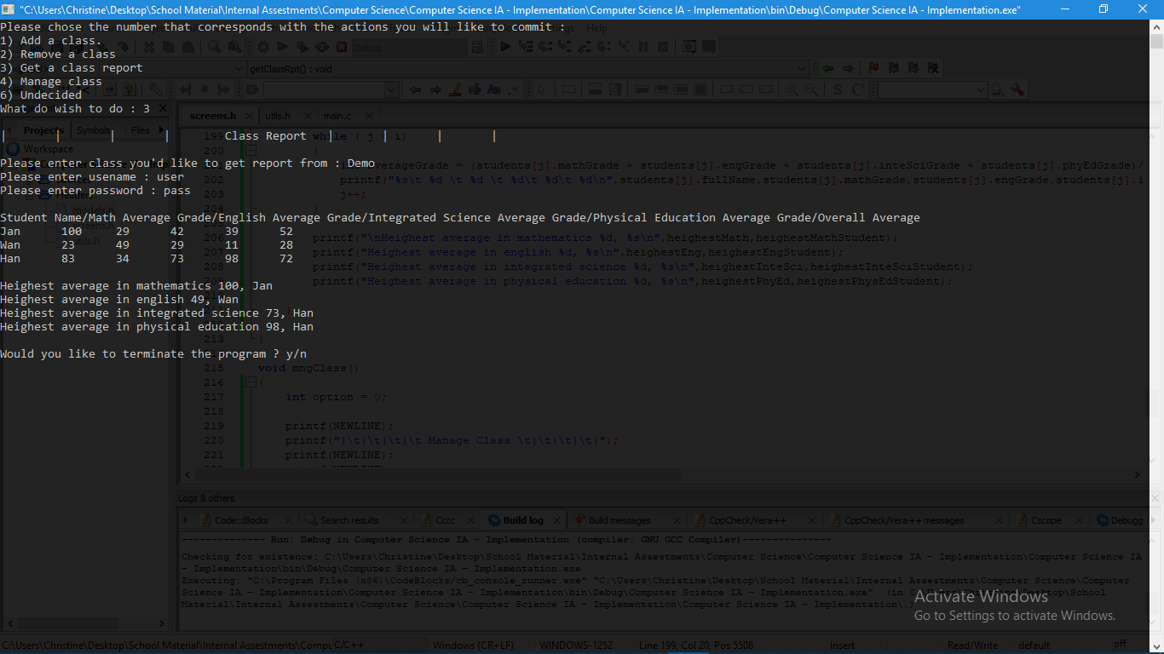

Figure 1.

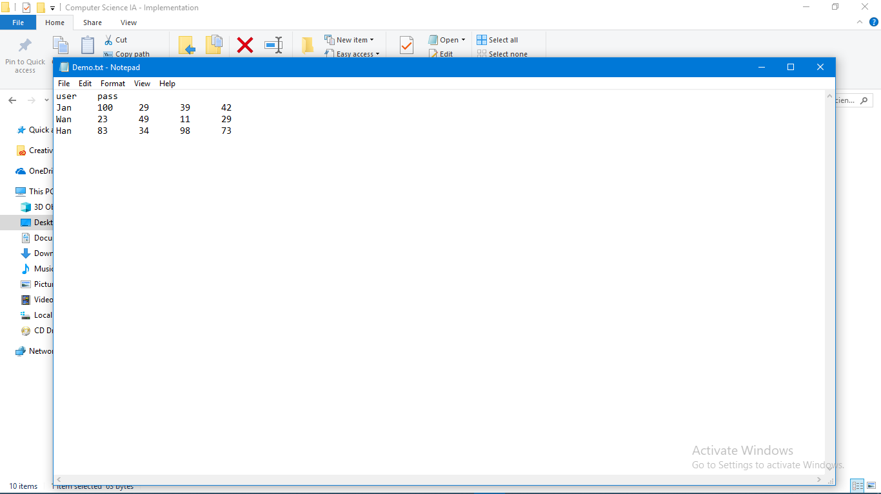

Figure 2

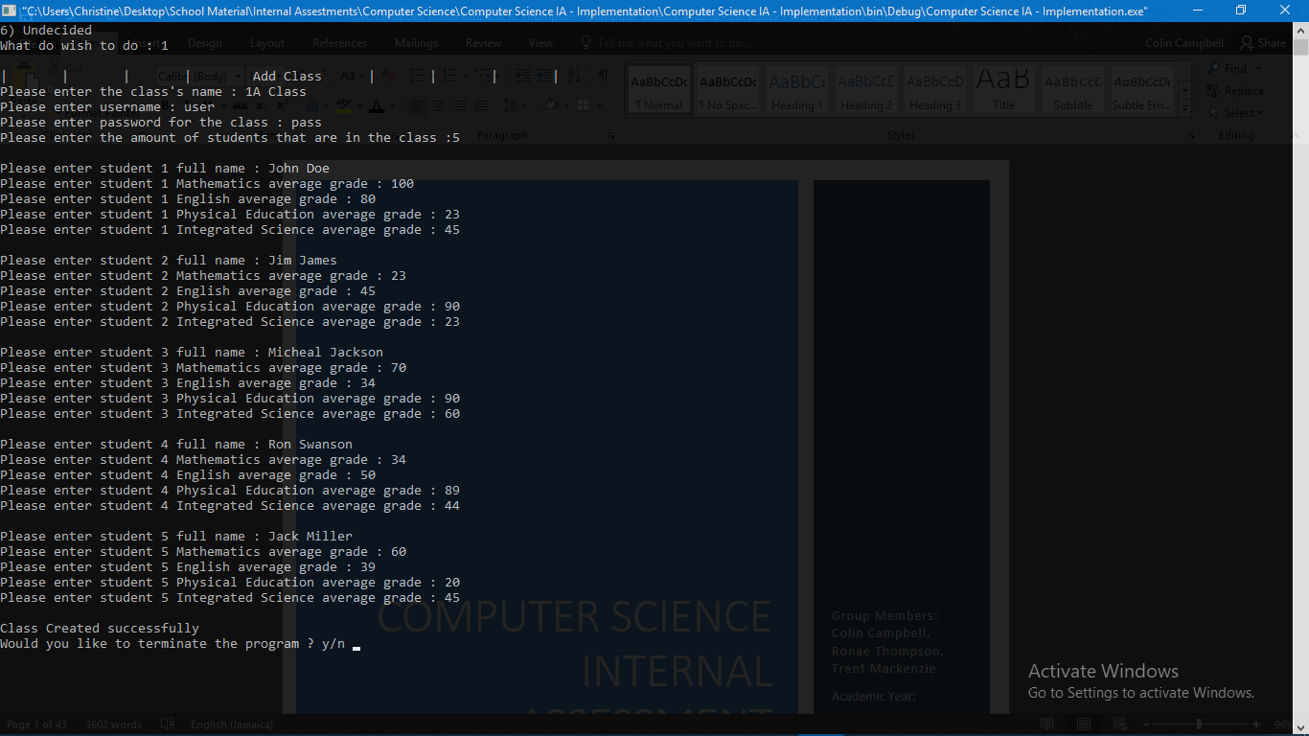

Figure 3